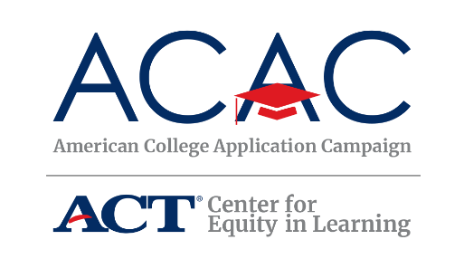
Contact: Lisa King, Director at lisa.king@act.org
#WhyApply 2023 Social Media Toolkit
This fall, students across the country will be submitting college applications and celebrating their plans for the future. Many of them will do so as schools in all 50 states and the District of Columbia host American College Application Campaign (ACAC) events. To celebrate college application season and our students, ACAC encourages participation in the #WhyApply social media campaign.
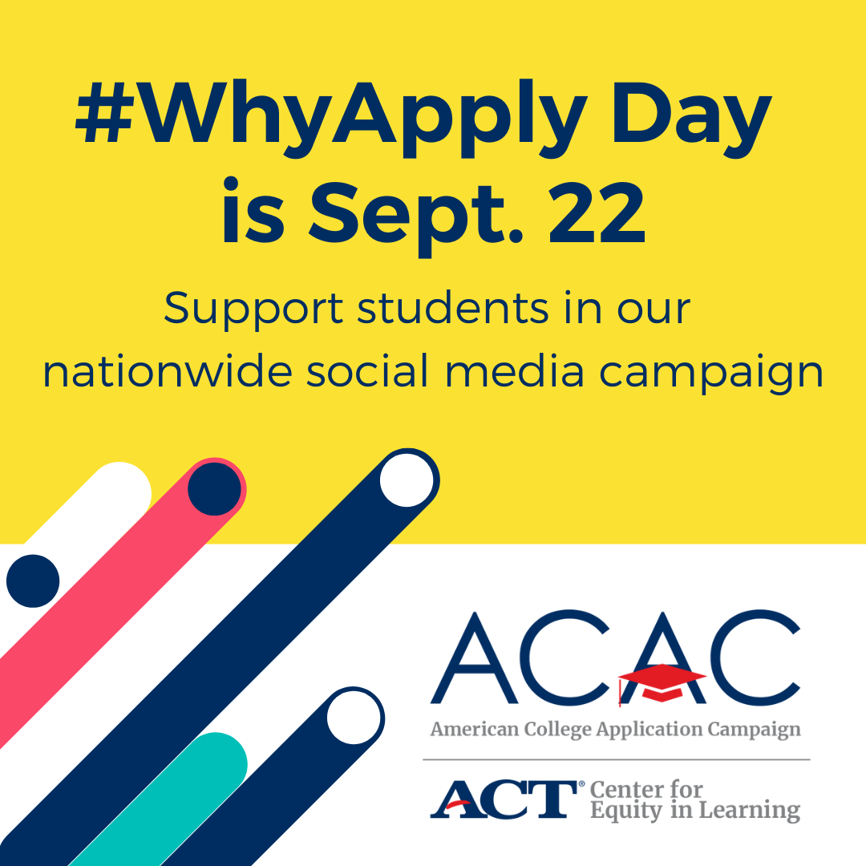
Join ACAC on Friday, September 22, 2023 for #WhyApply Day
by heading to social media and answering the question,
“Why apply to college?”
#WhyApply Day celebrates the college application season by sharing supportive
and motivating messages on social media about the importance of applying to
college. Whether applying to a certificate program, two- or four-year college or
universityit’s important to celebrate this critical and necessary step on the journey
to postsecondary education.
How You Can Participate
1. Share your #WhyApply on social media.
- Print a #WhyApply Selfie Printout or use a blank piece of paper with the hashtag on it.
- Write your response to the question “Why apply to college?” on it.
- Put on your college gear and take a photo with your #WhyApply statement.
- On September 22, post your photo or statement to your personal or organization’s social media channels using the hashtag #WhyApply and tag the American College Application Campaign.
Twitter: @American_CAC | Facebook: @americancac | Instagram: @American_CAC
_____________________________________________________________________________
Sample posts to use on #WhyApply Day:
Because you can’t go if you don’t apply Because my parents didn’t
Because you deserve to experience all college has to offer Because you are college material
To open new doors of opportunity that will last a lifetime To learn something new

Get creative! We love seeing the pictures and your smiling faces, but there are other ways to participate. If you’re camera shy, draw a picture or simply update your status. If you prefer video, share a brief video with your #WhyApply statement.
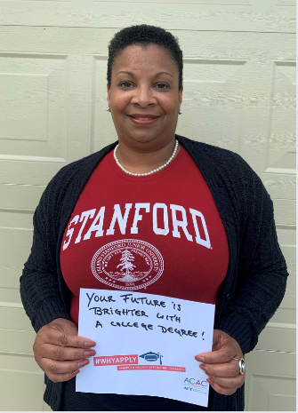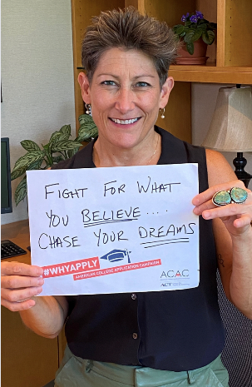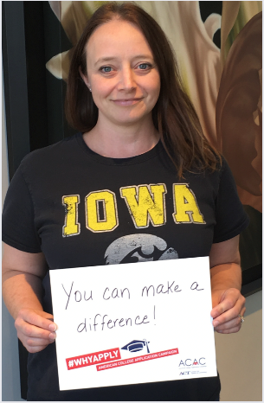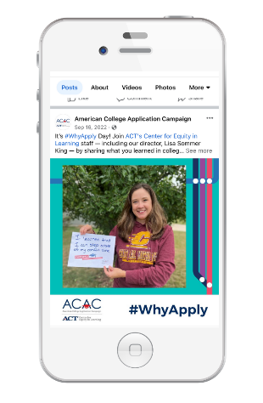

2. Promote #WhyApply on social media (share images/text).
Help us spread the word to ensure more educators and mentors join in the celebration! Post on social media 1-2 weeks before #WhyApply Day to invite others to share their own reasons on September 22. You can find editable Canva graphics in our toolkit; just add your own image and logo.
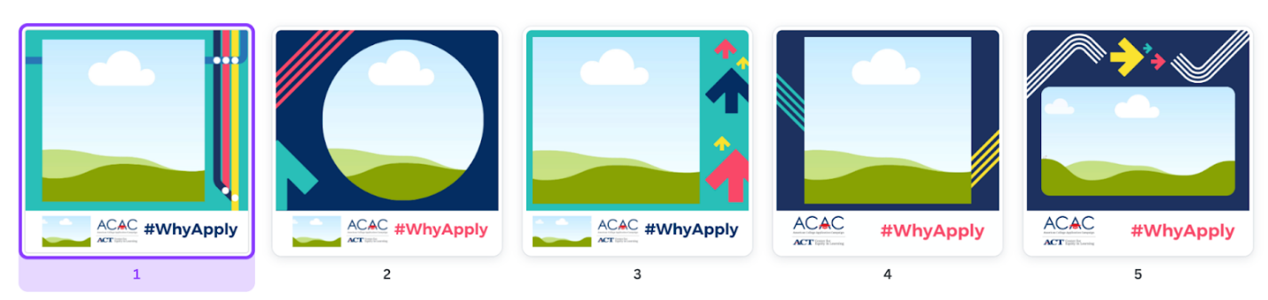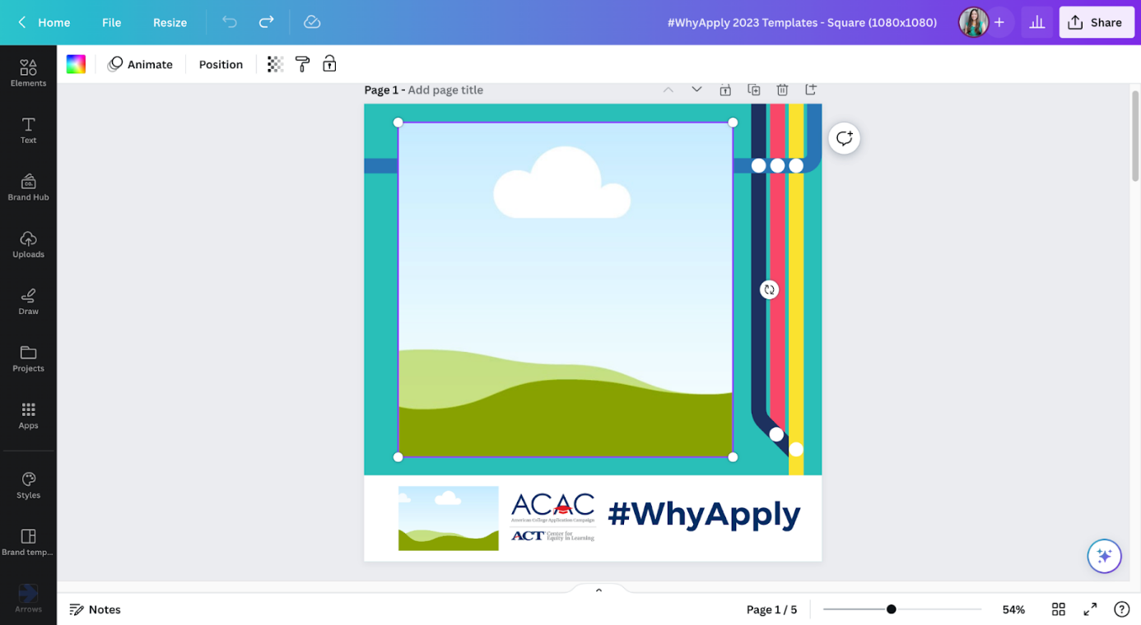

3. Invite colleagues and networks to share their #WhyApply.
Send an email to your staff or include #WhyApply in your newsletter 1-2 weeks before #WhyApply Day. Copy and paste the image below or download other sizes at https://equityinlearning.act.org/acac/resources/why-apply/
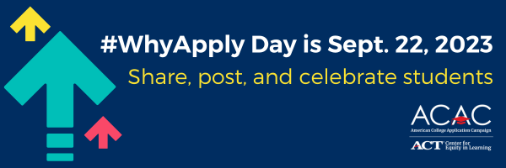
Sample newsletter copy (short form/blurb):
What did you learn in college? Join us and the American College Application Campaign in celebrating #WhyApply Day on Friday, September 22. Share what you learned in college on social media. Use the template or make a video. Post with the #WhyApply hashtag and help inspire students as they begin their college applications. Learn more.

Sample newsletter copy (long form):
Subject line: Celebrate #WhyApply Day this September 22
At <ORGANIZATION NAME>, we believe every student should have the opportunity to pursue postsecondary education, and we know school staff are the best support system to help students believe it too. We’re excited to work alongside the American College Application Campaign (ACAC), an initiative of ACT’s Center for Equity in Learning, for #WhyApply Day 2023.
ACAC supports coordinators, counselors, educators, and community partners from thousands of communities across the country to organize events that encourage students to apply to college and support them throughout their application process. To celebrate the nearly 300,000 students who will participate in these application events, #WhyApply Day kicks off the application season and provides encouragement for the students.
This year #WhyApply Day is on Friday, Sept. 22. Show your support by wearing your college gear and sharing why you believe students should apply to college and/or why you applied to college, using the hashtag #WhyApply on social media.
Not sure what to post? Try these tips to express your reasons in engaging ways:
- Type a short response in your status.
- Make a video of yourself, your kids, or your friends answering the question.
- Draw a picture illustrating your reasons.
- Write your answer on a piece of paper (feel free to use the #WhyApply template provided) and post a photo of you holding it.
- Share an image or photo with your reason.
For more resources, including social media post templates, download the toolkit https://equityinlearning.act.org/acac/resources/why-apply/.
Your participation in #WhyApply Day and your year-round support for our students make a significant difference in their lives. By helping them feel capable and confident as they prepare to take the next step in their education journeys, you contribute to their success. Should you have any questions, please don't hesitate to reach out to our office.
Join us in empowering students, and let’s make #WhyApply Day 2023 a memorable and meaningful event!

