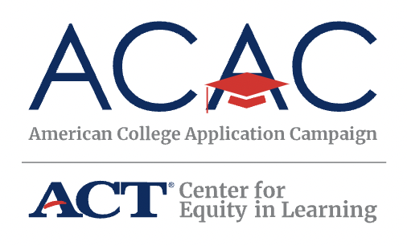

NEWSLETTER SAMPLE COPY
Prepared by Piper & Gold June 2023

At <ORGANIZATION NAME>, we believe every student should have the opportunity to pursue postsecondary education, and we know school staff are the best support system to help students believe it too. We’re excited to partner with the American College Application Campaign (ACAC), an initiative of ACT’s Center for Equity in Learning, for #WhyApply Day 2023.
ACAC supports counselors, college advisors, educators, and community partners from thousands of communities across the country to organize events that encourage students to apply to college and support them throughout their application process. To celebrate the nearly 300,000 students who will participate in these application events, #WhyApply Day kicks off the application season and provides encouragement for the students.
This year #WhyApply Day is on Friday, Sept. 22. Show your support by wearing your college gear and sharing why you believe students should apply to college and/or why you applied to college, using the hashtag #WhyApply on social media.
Not sure what to post? Try these tips to express your reasons in engaging ways:
- Type a short response in your status.
- Make a video of yourself, your kids, or your friends answering the question.
- Draw a picture illustrating your reasons.
- Write your answer on a piece of paper (feel free to use the #WhyApply template provided) and post a photo of you holding it.
- Share an image or photo with your reason.
For more resources, including social media post templates, download the toolkit.
Your participation in #WhyApply Day and your year-round support for our students make a significant impact in their lives. By helping them feel capable and confident as they prepare to take the next step in their educational journey, you contribute to their success. Should you have any questions, please don't hesitate to reach out to our office.
Join us in empowering students, and let’s make #WhyApply Day 2023 a memorable and impactful event!

